Consider the pattern below with White, Grey and Dark grey circles
(skip the concepts which you are not familiar with)

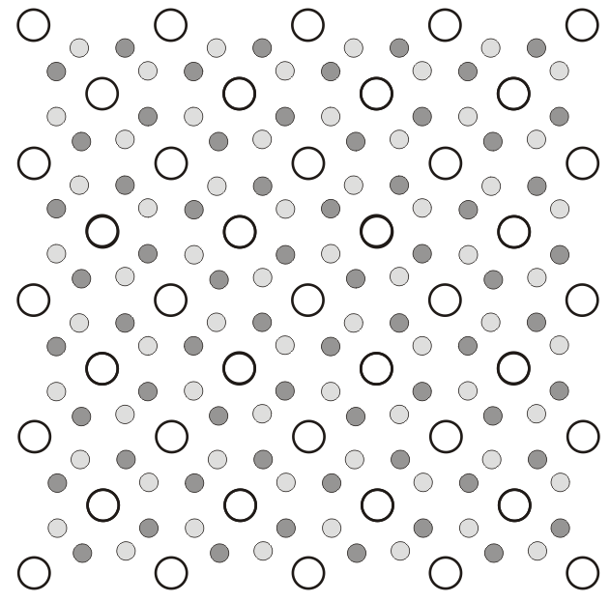Fig.1

Let us do the following:

- Draw the conventional UC (name the UC and calculate the number of lattice points per cell).
- Draw alternate non-primitive cells.
- Identify the lattice points and the motif (name the Bravais lattice).
- Draw the fundamental (shortest) lattice translation vector and write its Miller Indices.
- Overlay symmetry operators on the figure.
- Draw some non-primitive unit cells.
- Identify the space group (Hermann-Mauguin symbol) and the Asymmetric Unit
- How to place the entities (filled and open circles) using Wyckoff labels/positions.

➢ Various entities are overlaid on the pattern (the solutions are shown but some thinking is required to ensure that things are in place and right!)

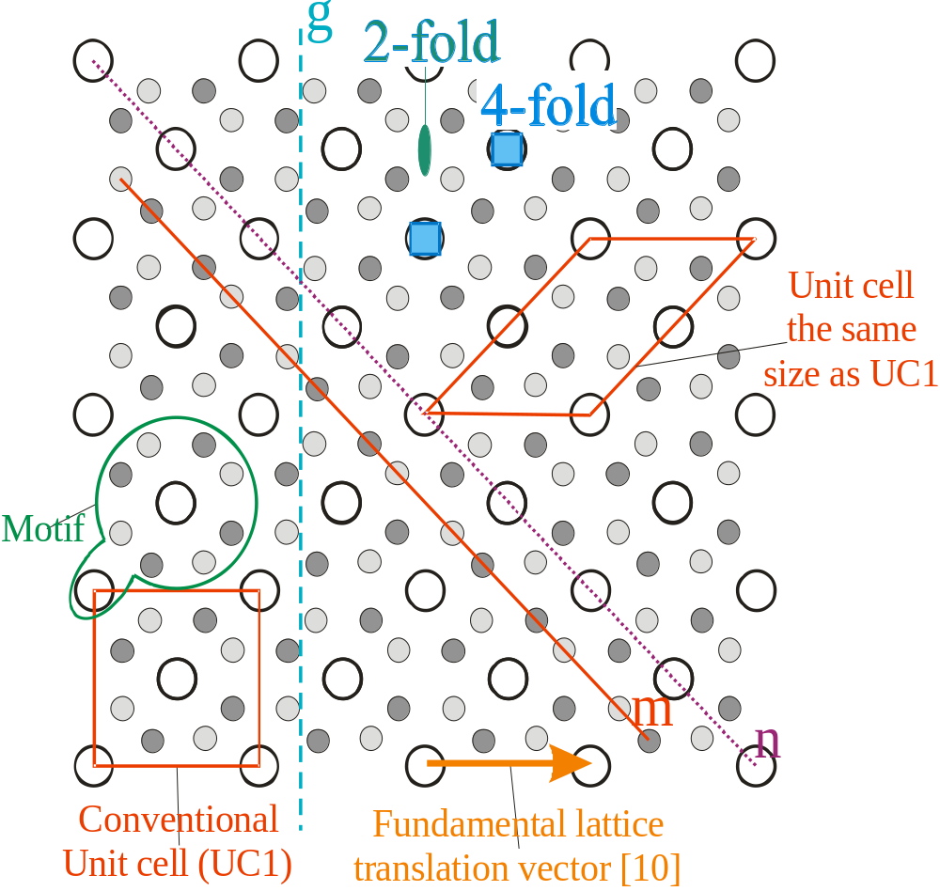 Fig.2
Key: m → mirror, g → glide (reflection), n → diagonal glide

Notes:
- The central white circle in UC1 is NOT a lattice point if the corners are chosen to be lattice points (Why?)
- Though UC1 and UC2 have the same size UC1 is the conventional choice due to its higher symmetry (which is commensurate with that of the lattice- e.g. both have a 4-fold)
- The motif contains: 2 while circles, 3 dark grey circles and 3 light grey circles
(Can you ensure that this motif repeats at every lattice point?)
- One of each type of entity is marked → symmetry elements (especially translation) will overlay the complete set.

➢ Alternate unit cells (non-primitive)

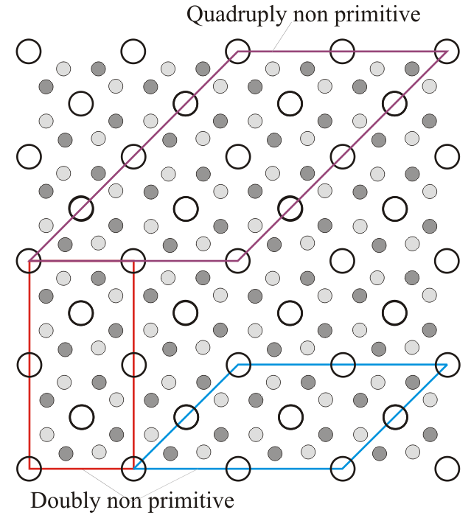Fig.3

Cotd…
➢ The UC with entities overlaid are shown below

(a)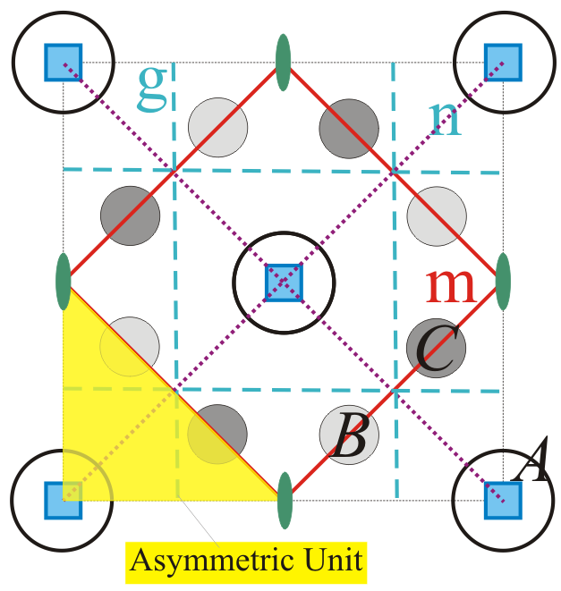 (b) 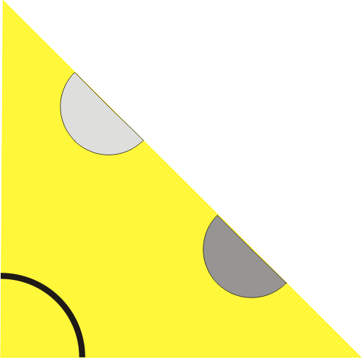
Asymmetric unit with portions/parts of the circular entities
Fig.4

- Bravais Lattice = Primitive square lattice
- No. of lattice points per cell = 1 (UC1 or UC2 → note that their sizes are same)
- Space group = p4gm; No. 12.
- Asymmetric Unit: x∈[0, 0.5], y∈[0, 0.5], y ≤ (0.5 − x)

Notes:
- Asymmetric unit is a tile (region of space), which along with the space group tiles space (2D here). Hence, truly speaking asymmetric unit does not contain any entities.
- In the figure above (Fig.4b), the asymmetric unit is shown overlaid with the entities (parts of circles- filled and open).

Cotd…
➢ Now we place the circles using Wyckoff labels/positions

 | Wyckoff position | Coordinates | Site  Symmetry | x | y | Occupancy
A (Unfilled circle)  | 2a | (0, 0), (½, ½) | 4.. | - | - | 1
B (light grey circle)  | 4c | (x, x + ½),  (−x, −x + ½)  (−x + ½, x)  (x + ½, −x) | ..m | 0.35 | -
C (dark Grey circle)  | 4c | (x, x + ½),  (−x, −x + ½)  (−x + ½, x)  (x + ½, −x) | ..m | 0.15

Notes:
When points are plotted according to the coordinates given in the table (for say 4c grey circle); some of the points are in the negative x or y axis. Unit values are added to these appropriately to bring them back into the unit cell.
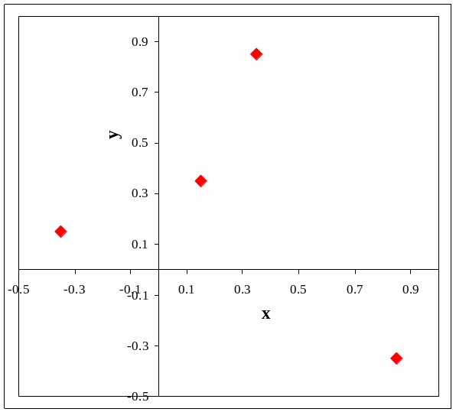Replot → 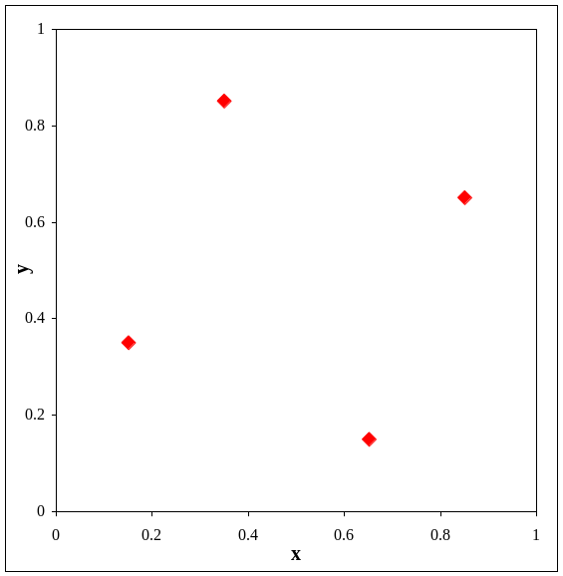

Please also refer to: from_L+M_SG.ppt

