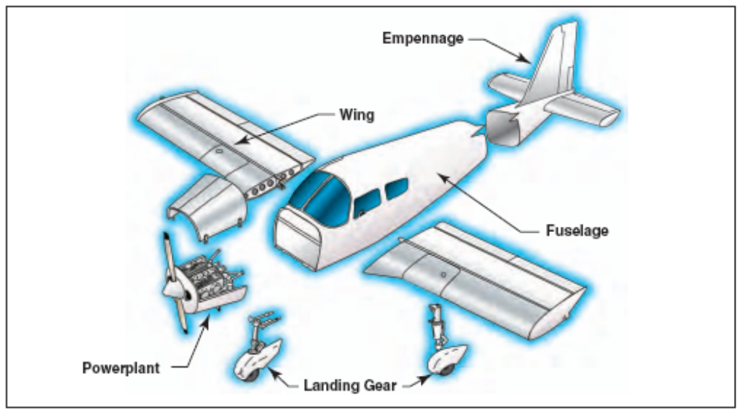

Figure 1: Parts of an aircraft

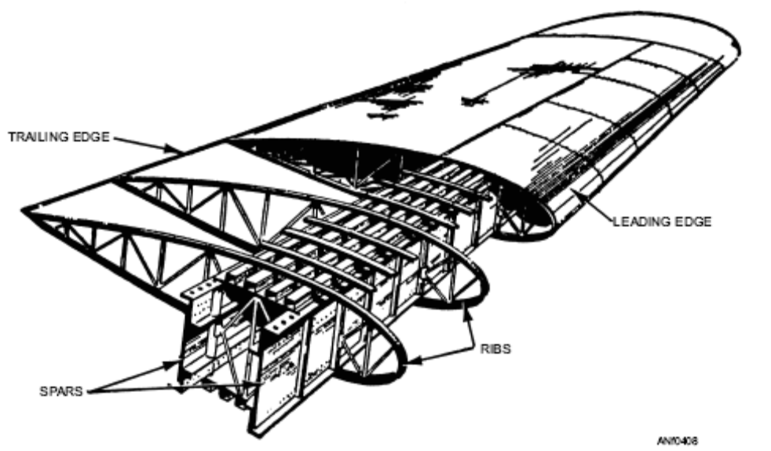

Figure 2 (a): Construction of a typical aircraft wing

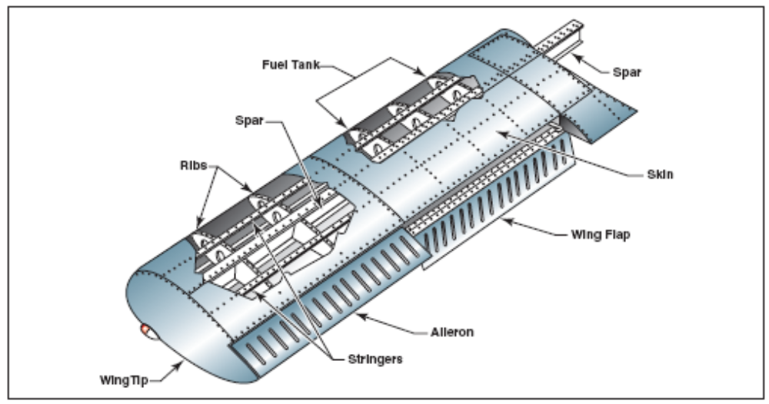
Figure 2(b): Wing construction

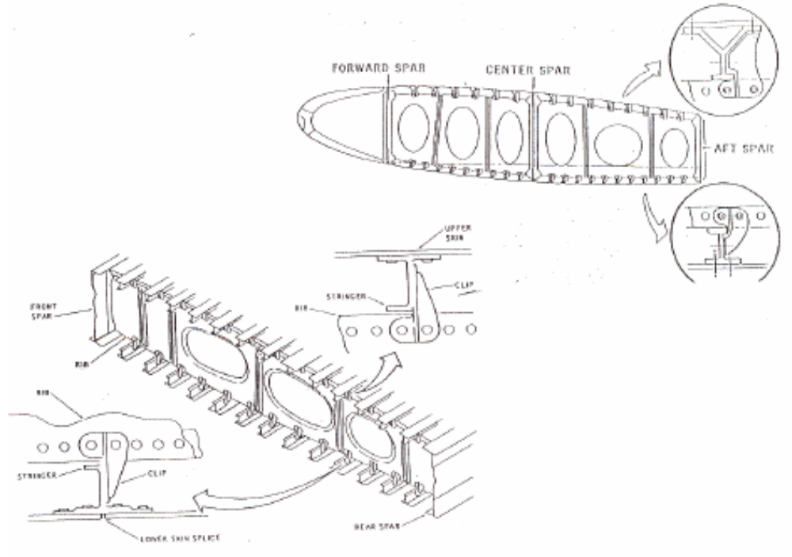
Figure 3: Wing box cross-section

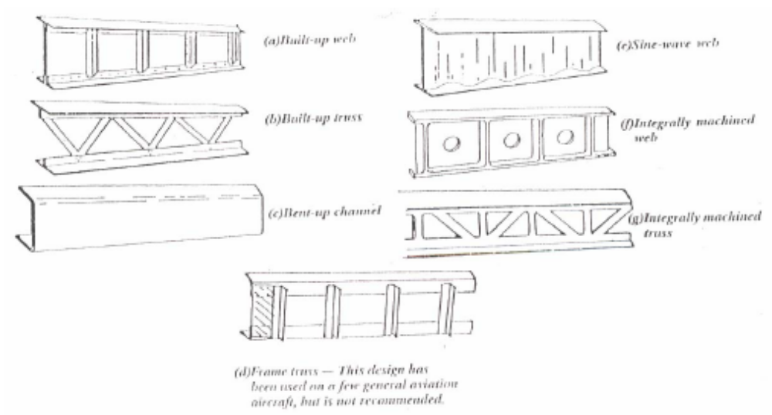
Figure 4: Typical wing spar configurations

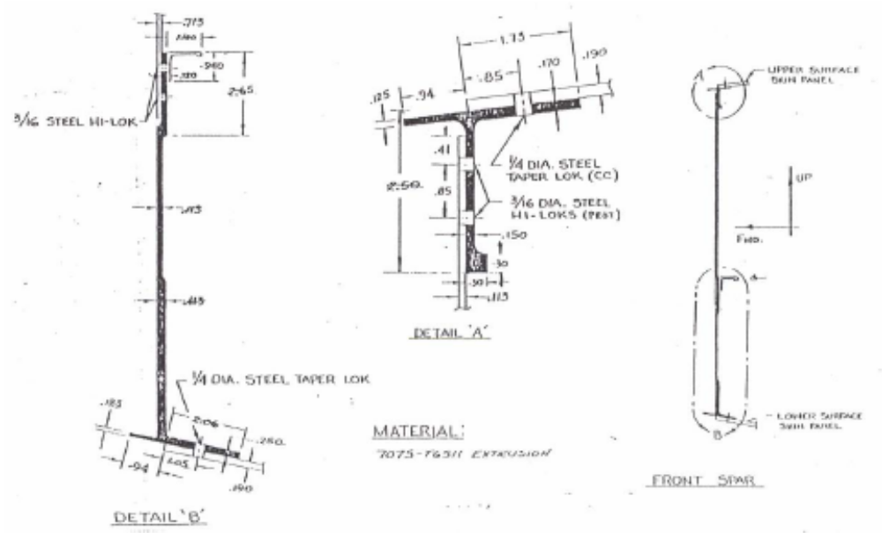

Figure 5: Wing front spar (of C141 wing)

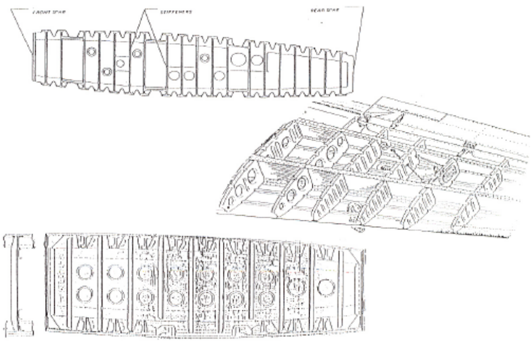
Figure 6: Typical wing rib configurations

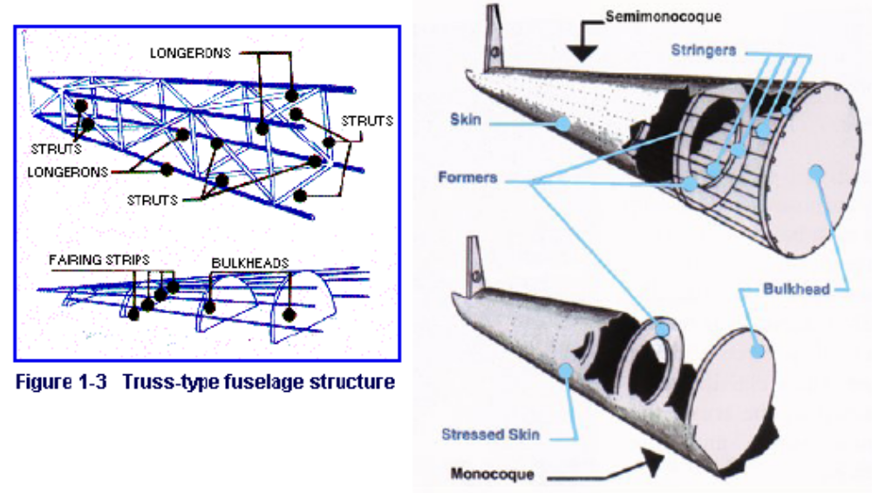
Figure 7: Fuselage structure types

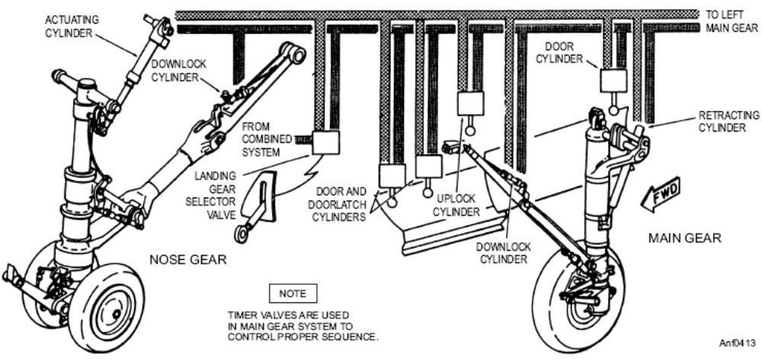
Figure 8(a): Typical landing gear system

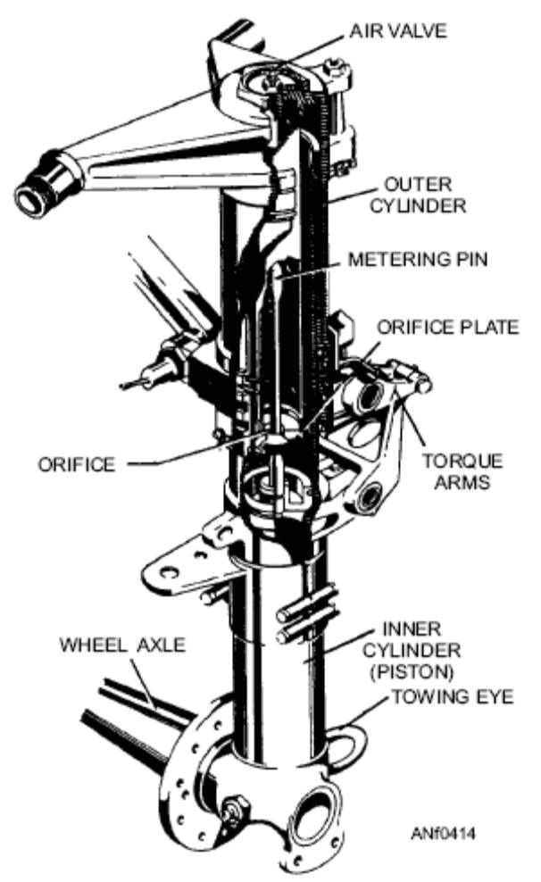
Figure 8(b): Internal construction of a shock strut

Typical transport aircraft wing structural weight distribution

Engine 20%
Interior: 15%
System: 20%
Airframe: 45% 1) Wing 45% 2) Fuselage 45% 3) Tail 10%

Skin stringers and spar caps | 39%
Access doors, splicers and attachments | 8%
Spar webs | 7%
Ribs | 5%
Bulkheads | 8%
LE and TE | 11%
Secondary structures | 4%
Control surfaces | 18%

