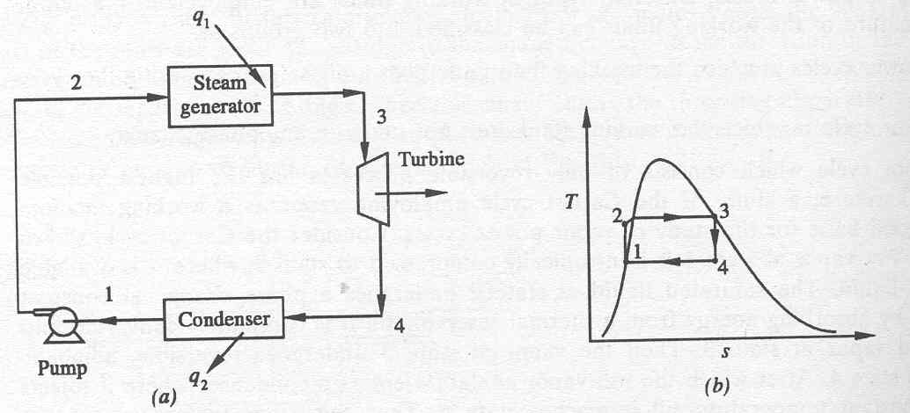
Ideal Rankine Cycle

(a) Schematic representation of an ideal Rankine cycle (b) T-s diagram of an ideal Rankine cycle

Application of the First law of thermodynamics to the control volume (pump, steam generator, turbine and condenser), gives

Work done on pump, per kg of water, W_{P}= h₂-h₁

Energy added in steam generator, q₁= h₃-h₂

Work delivered by turbine, W_{T}= h₃-h₄

Energy rejected in the condenser, q₂= h₄-h₁
The thermal efficiency of the Rankine cycle is given by,

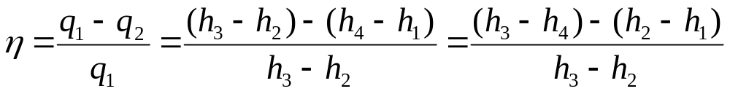

η= Net work done
----------------------
Energy absorbed

Practical Rankine cycle

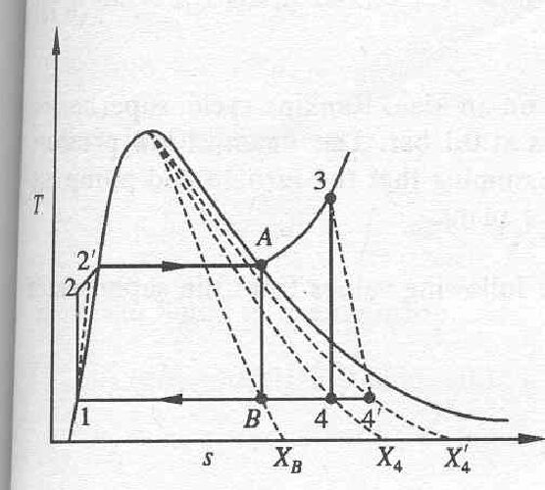

Pump and Turbine do not operate isentropically in practice.

The practical Rankine cycle is shown as 1-2’-3-4’-1.

In the actual turbine, the work delivered is less than the isentropic turbine. Similarly, the work consumed by an actual pump is greater than the work consumed by an isentropic pump.

That is,

h₃-h₄’ < h₃-h₄

h₂’-h₁ > h₂-h₁

Thermal efficiency of a practical Rankine cycle,

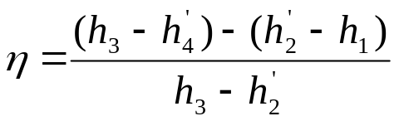

The performance of an actual turbine or pump is usually expressed in terms of isentropic efficiency.
Isentropic efficiency of turbine (η_{T}) is defined as the ratio of ‘Work delivered by actual turbine’ to ‘Work delivered by an isentropic turbine’.

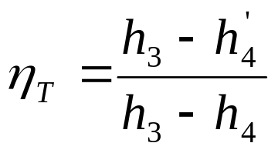

Isentropic efficiency of pump (η_{P}) is defined as the ratio of ‘Work required by isentropic pump’ to ‘Work required by actual pump’

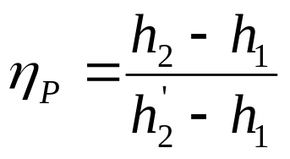

Methods to increase the efficiency of the Rankine cycle

Basic idea: Increase the average temperature at which heat is transferred to the working fluid in the boiler, or decrease the average temperature at which heat is rejected from the working fluid in the condenser.

1. Lowering the condenser Pressure:-

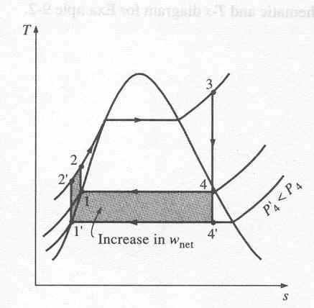

Lowering the operating pressure of the condenser lowers the temperature at which heat is rejected. The overall effect of lowering the condenser pressure is an increase in the thermal efficiency of the cycle.

2. Superheating the steam to high temperatures:-

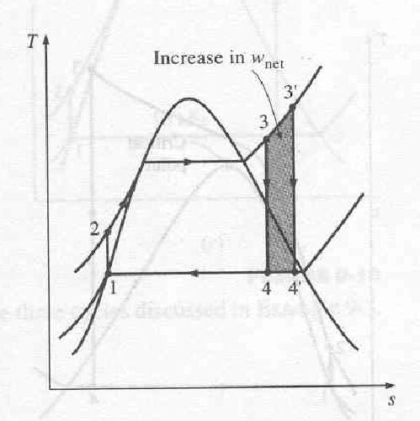

The average temperature at which heat is added to the steam can be increased without increasing the boiler pressure by superheating the steam to high temperatures.

Superheating the steam to higher temperatures has another very desirable effect: It decreases the moisture content of the steam at the turbine exit.

3. Increasing the Boiler pressure:-
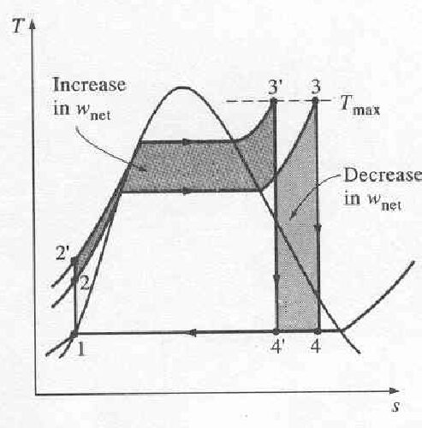

Increasing the operating pressure of the boiler, automatically raises the temperature at which boiling takes place.

This raises the average temperature at which heat is added to the steam and thus raises the thermal efficiency of the cycle..

Reheat Rankine Cycle

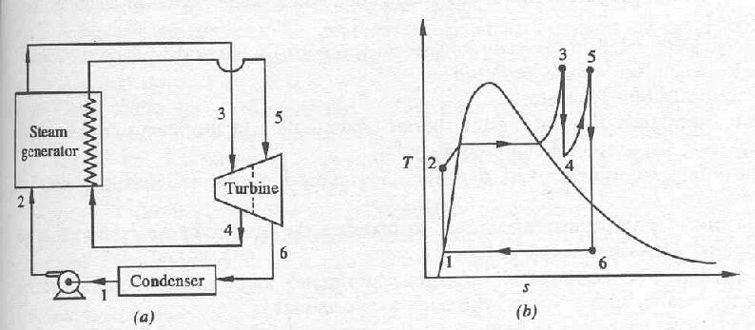
(a) schematic representation of a reheat Rankine cycle (b) T-s diagram of a reheat Rankine cycle

The energy added ( per unit mass of steam ) in the steam generator is given by,

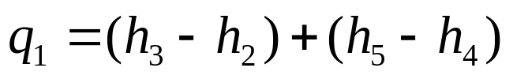

The energy rejected in the condenser,

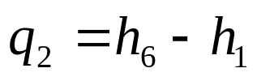

The thermal efficiency,

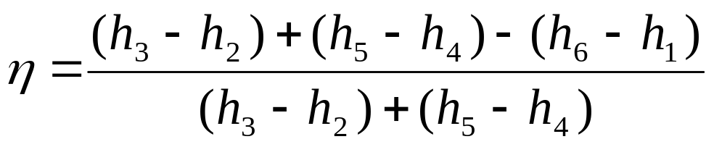

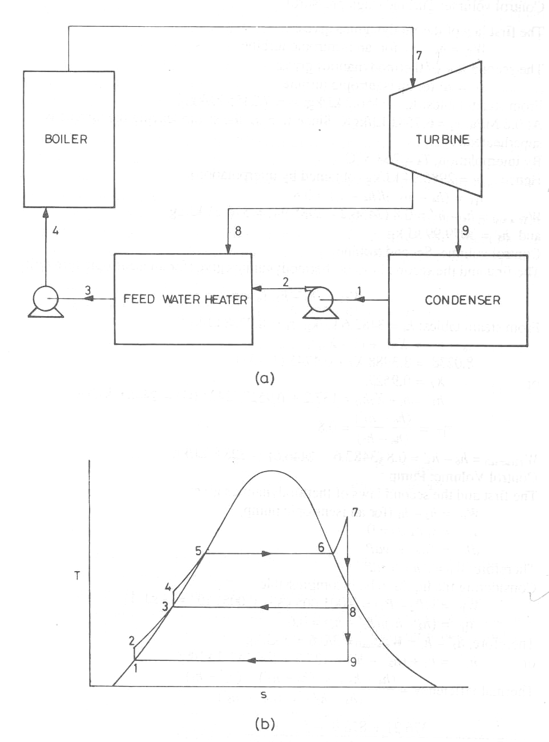
Regenerative Cycle

- schematic diagram (b) T-s diagram

Consider the feed water heater as the control volume and apply the first law of thermodynamics to obtain,

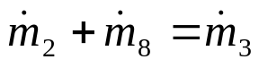

and 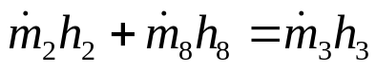

or 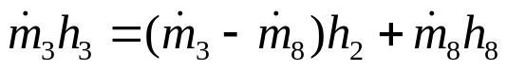

or 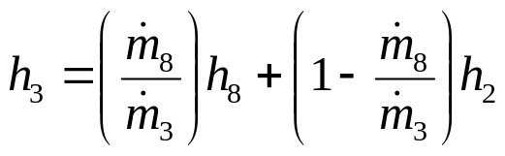

Let, 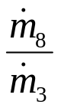=Y’= the fraction of steam extracted
from the turbine for preheating

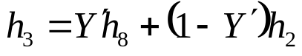

Energy added in the boiler per unit mass of the working fluid,

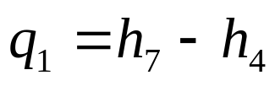

Energy rejected in the condenser,

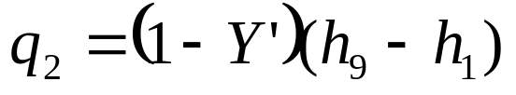

Thermal efficiency,

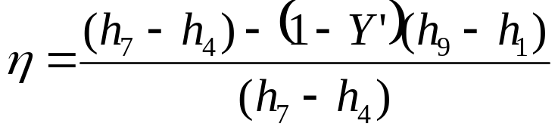

The work output of the turbines =

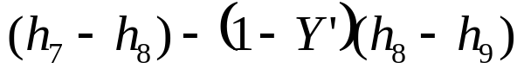

Work spent on the pumps =

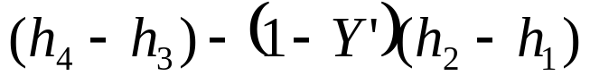

Air standard Otto Cycle

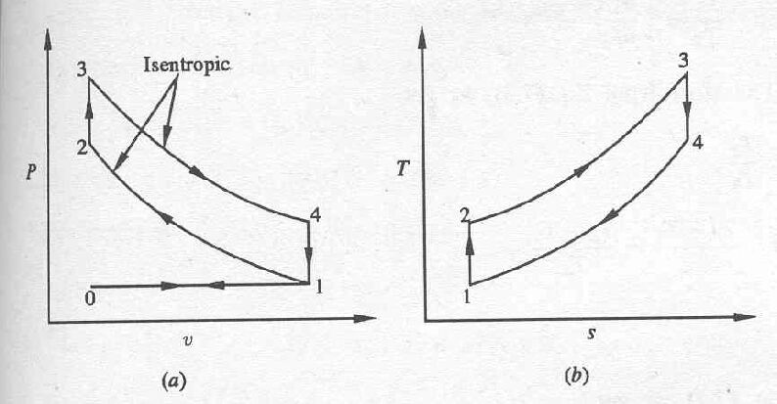
Air standard Otto cycle on (a) P-v diagram (b) T-s diagram

Processes: -

0-1: a fresh mixture of fuel-air is drawn into the cylinder at constant pressure

1-2: isentropic compression

2-3: energy addition at constant volume

3-4: isentropic expansion
4-1: combustion products leave the cylinder

1-0: the piston pushes out the remaining combustion products at constant pressure

Since the net work done in processes 0-1 and 1-0 is zero, for thermodynamic analysis, we consider the 1-2-3-4 only.

The thermal efficiency of the cycle is given by

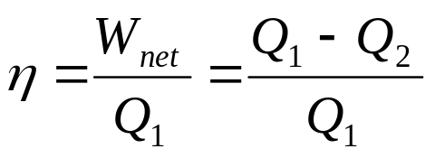

where Q₁ and Q₂ denote the energy absorbed and rejected as heat respectively.

For a constant volume process Q=ΔU. If ‘m’ is the mass of the air which is undergoing the cyclic process,

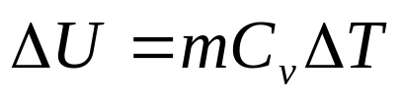

Energy is absorbed during the process 2-3

Energy is rejected during the process 4-1

Hence,
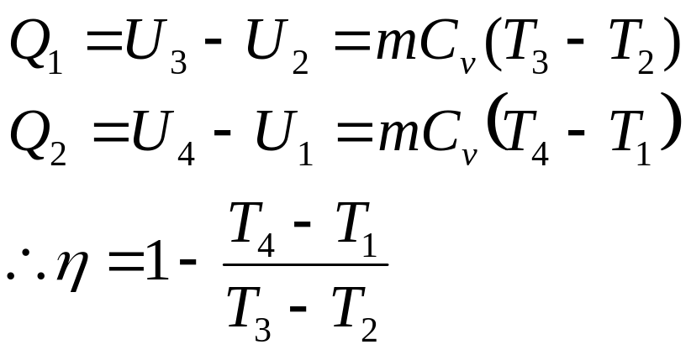

For an ideal gas undergoing an isentropic process (process 1-2 and 3-4),

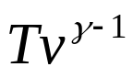 = constant

Hence,

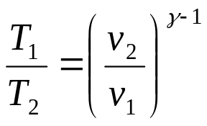

and 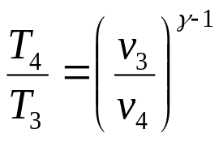

But v₁=v₄ and v₂=v₃. Hence we get,

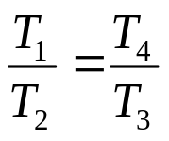 or 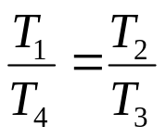

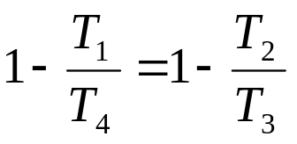 or 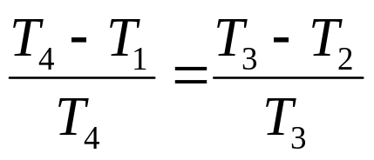

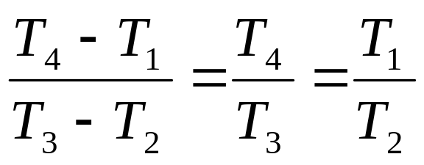

Hence, 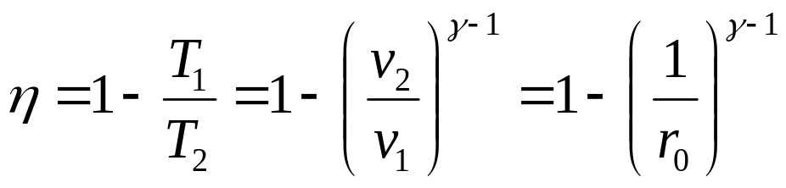

Where the compression ratio r₀ is defined as

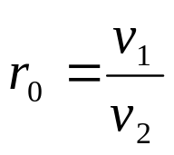

Sometimes it is convenient to express the performance of an engine in terms of Mean effective Pressure, P_{m}, defined as the ratio of “Net work done” to “Displacement volume”

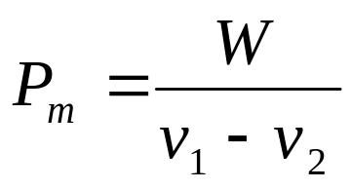

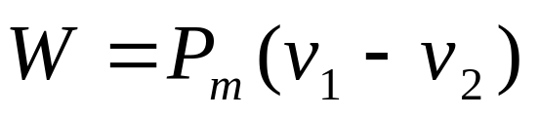

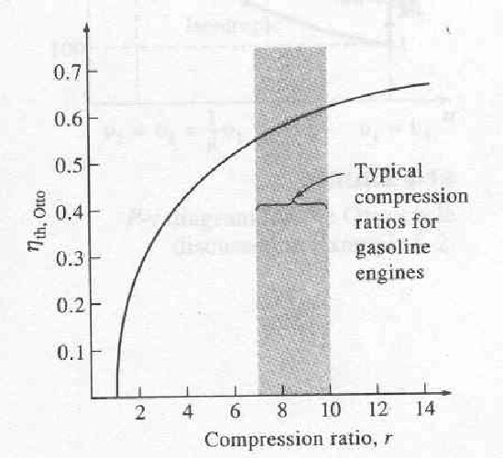

Thermal efficiency of the ideal Otto cycle as a function of compression ratio (γ=1.4)

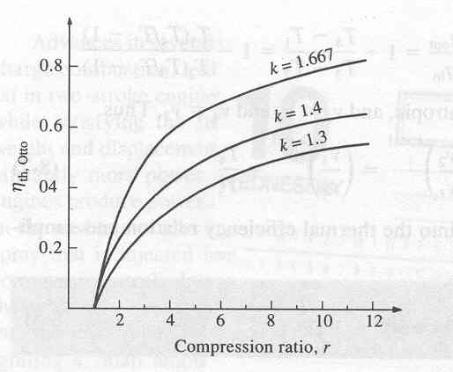

The thermal efficiency of the Otto cycle increases with the specific heat ratio, γ of the working fluid.

Air standard Diesel cycle

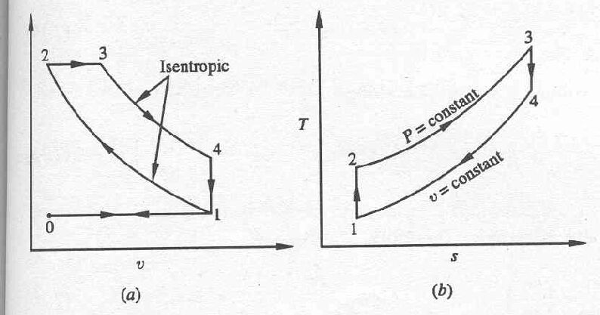
Diesel cycle on (a) P-v diagram (b) T-s diagram

Processes: -

0-1: fresh air is drawn into the cylinder

1-2: isentropic compression

2-3: constant pressure energy addition

3-4: isentropic expansion

4-1: combustion products leave the cylinder

1-0: remaining combustion products are exhausted at constant pressure

Defining cutoff ratio, r_{c} as,

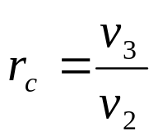

For a constant pressure process (2-3),

Q=ΔH.

Hence, the energy addition during process 2-3,

where ‘m’ is the mass of gas undergoing the cyclic change.

The energy rejection during the process 4-1,

The thermal efficiency, η is given by

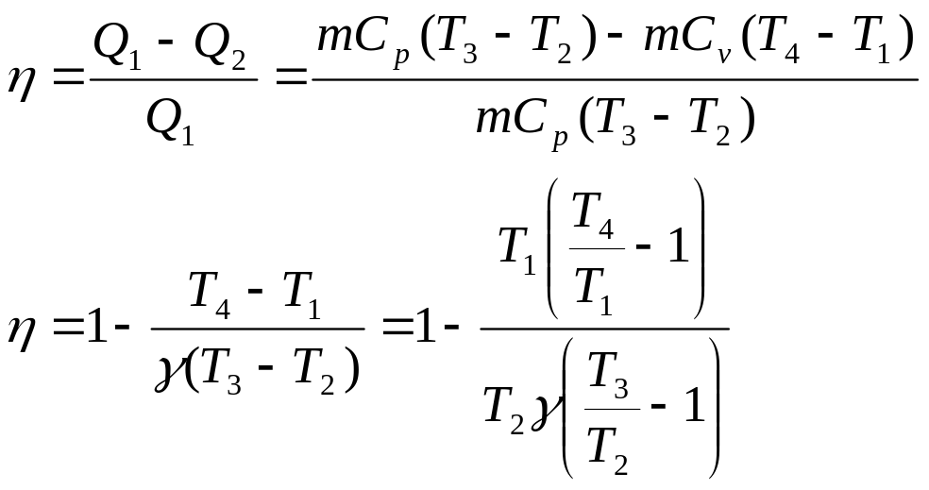

Since the process 1-2 is isentropic,

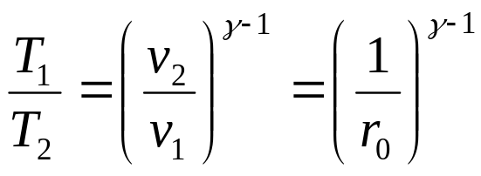

Since the process 4-1 is a constant volume process,

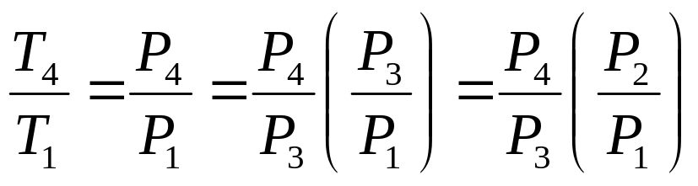

since P₂=P₃

The processes 1-2 and 3-4 are isentropic. Hence,

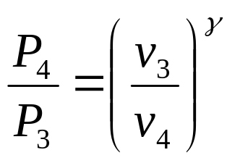 and 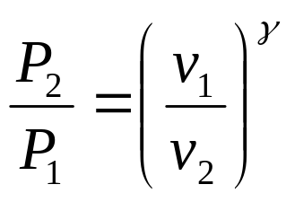

Hence we get,

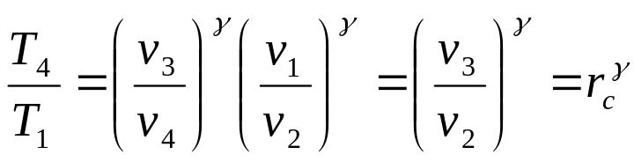

For the constant pressure process,

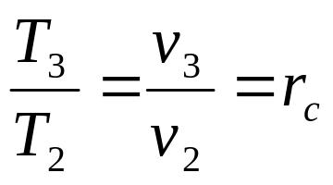

Hence the efficiency becomes,

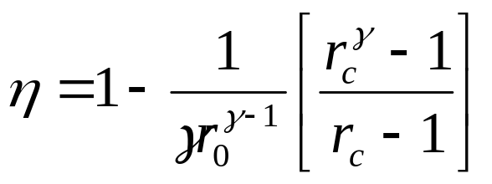

The mean effective pressure of an air standard diesel cycle is given by,

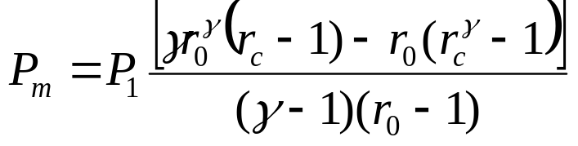

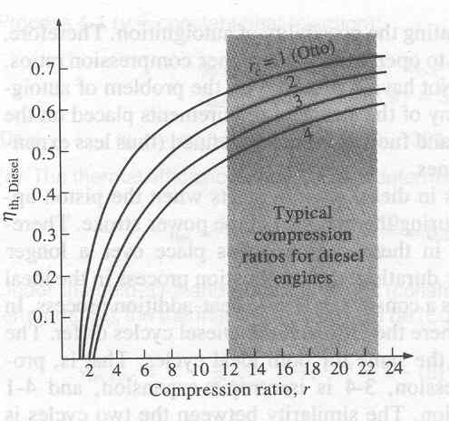

Thermal efficiency of the ideal diesel cycle as a function of compression and cutoff ratios (γ=1.4)

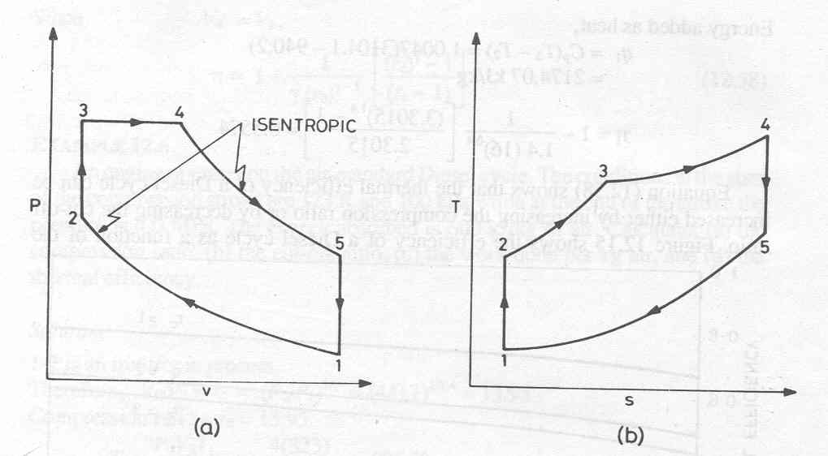
Air standard Dual cycle

Dual cycle on (a) P-v diagram (b) T-s diagram

Energy addition is in two stages: Part of energy is added at constant volume and part of the energy is added at constant pressure

Energy added, q₁

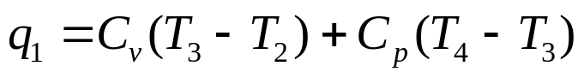

Energy rejected, q₂

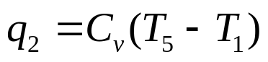

Thermal efficiency, η

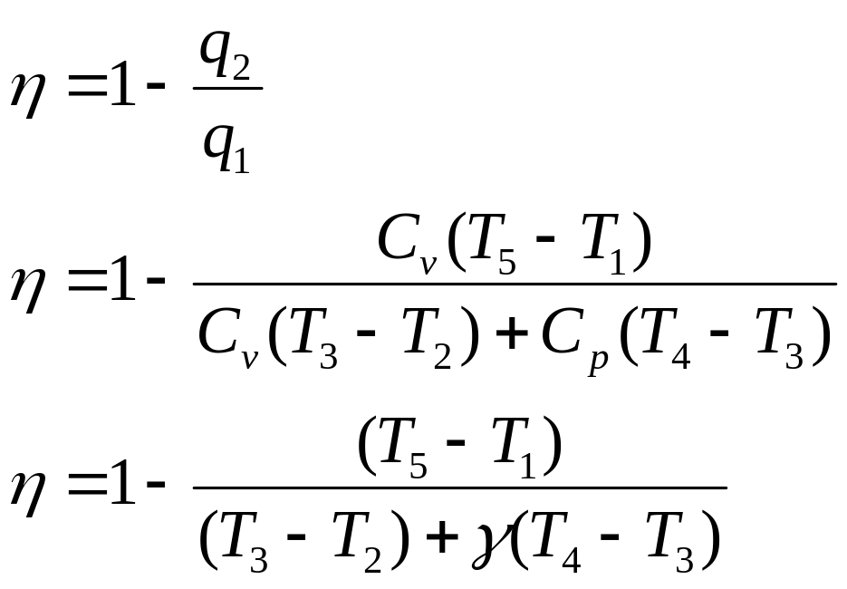

The efficiency can be expressed also in terms of,

Compression ratio, r₀ = V₁/V₂

Cut-off ratio, r_{c} = V₄/V₃

Constant volume pressure ratio, r_{vp}= P₃/P₂

